Python Programming (05CS2104)
Lab Manual (2025-26)
Program: M.Sc. (Cyber Security & Cyber Law)
Semester: 1
Name of the Student: Jenil Makwana
Enrolment No.: 92600565009

INDEX

Lab | Program | Date | Remarks | Signature
1 | Python Program to Print Hello World. | 9-8-26
2 | Python program to do arithmetical operations | 9-8-26
3 | Python program to swap two variables | 9-8-26
4 | Python Program to Find the Factorial of a Number | 9-8-26
5 | Python Program to Print the Fibonacci sequence | 9-8-26
6 | Python program to print the elements of an array | 11-8-26
7 | Python program to print the largest element and smallest element in an array | 11-8-26
8 | Python program to add two matrix using array and function | 11-8-26
9 | Python program to print the sum of all elements in an array | 11-8-26
10 | Python Program to concatenate two strings | 11-8-26
11 | Python Programs to perform various operations on Strings using functions | 1-9-26
12 | Python Programs to demonstrate use of list and various functions of it | 1-9-26
13 | Python Programs to demonstrate use of tuple and various functions of it | 1-9-26
14 | Python Programs to demonstrate the use of dictionary and various functions of it | 1-9-26
15 | Python Programs to demonstrate use of various arguments which can be passed to functions | 1-9-26
16 | Python Program to demonstrate the use of class | 1-9-26
17 | Python program to demonstrate the use of methods | 1-9-26
18 | Python programs to demonstrate the use of various forms of inheritance | 1-9-26
19 | Python programs to demonstrate use of modules | 1-9-26
20 | Python programs to demonstrate the use of exception handling | 1-9-26
21 | Python programs to demonstrate the use of file handling | 1-11-26
22 | Python Programs to demonstrate the use of various modes of files. | 1-11-26
23 | Python programs to demonstrate the use of regular expression | 1-11-26
24 | Python programs to demonstrate the use of database using mysql | 1-11-26
25 | Python Program to demonstrate the use of DataFrames in python | 1-11-26
26 | Python Programs to demonstrate different ways of creating DataFrames | 1-11-26
27 | Python Programs to create Pie chart | 1-11-26
28 | Python Programs to create histogram | 1-11-26
29 | Python Programs to create bar graph | 1-11-26
30 | Python Programs to create Line graph | 1-11-26
31 | Python Programs to work with Python Libraries useful for Cyber security. Program to generate hash values of a string using hashlib library. | 1-11-26
32 | Python Program using socket — Simple Port Scanner | 4-11-26
33 | Python Program using re — Detect Emails Using Regular Expressions | 4-11-26
34 | Python Program using os Library — Check Files in a Directory | 4-11-26
35 | Python program for whois lookup | 4-11-26
36 | Python program for Ping Scanner shows ip up or down | 4-11-26
37 | Python Programs to create Pie chart | 4-11-26
38 | Python Programs to create histogram | 4-11-26
39 | Python Programs to create bar graph | 4-11-26
40 | Python Programs to create Line graph | 4-11-26
41 | Write a Python program to perform a WHOIS lookup for a given domain name and display the result | 4-11-26
42 | Write a Python program to accept a domain name from the user and show basic WHOIS information. | 4-11-26
43 | Write a Python program to display the domain registrar name using WHOIS | 4-11-26
44 | Write a Python program to display the domain creation date using WHOIS. | 4-11-26
45 | Write a Python program to use the dig command to find the IP address of a website (example: google.com). Also, display the DNS records of a given domain | 4-11-26
46 | Python Program using re — Detect Emails Using Regular Expressions | 4-11-26
47 | Python Program using socket — Simple Port Scanner | 4-11-26
48 | Program to generate hash values of a string using hashlib library | 4-11-26
49 | Python Program using os Library — Check Files in a Directory | 4-11-26
50 | Python program for Ping Scanner shows ip up or down | 4-11-26

Enrollment/Roll No: 92600565009

Practical No. 1

Aim/ Objective: Python Program to Print Hello World.

Source Code:
#Name: Jenil Makwana
#Enrollment: 92600565009

#Q.1 Python Program to Print Hello World.

Print ("Hello World")

Output:
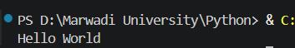

Conclusion: This program introduces the absolute foundation of Python syntax, demonstrating how to use the built-in print () function to display basic textual data directly to the console output.

Enrollment/Roll No: 92600565009

Practical No. 2

Aim/ Objective: Python program to do arithmetical operations

Source Code:
#Name: Jenil Makwana
#Enrollment: 92600565009

#Q.2 Python program to do arithmetical operations

num1 = int(input("Enter the First number: "))
num2 = int(input("Enter the Second number: "))

print ("The addition is :) ",num1+num2)
print ("The substraction is :) ",num1-num2)
print ("The multiplication is :) ",num1/num2)
print ("The division is :) ",num1*num2)
print ("The modulus is :) ",num1%num2)

Output:
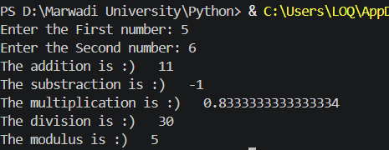

Conclusion: This script shows how Python handles math using standard arithmetic operators (+, -, *, /) to calculate values and store numerical results inside basic variables.

Enrollment/Roll No: 92600565009

Practical No. 3

Aim/ Objective: Python program to swap two variables

Source Code:
#Name: Jenil Makwana
#Enrollment: 92600565009

#Q.3 Python program to Swap two variables

num1 = int(input("Enter the 1st number: "))
num2 = int(input("Enter the 2nd number: "))

print (f"before swapping the values are num1: {num1} num2: {num2}")

num1,num2=num2,num1

print (f"After swapping the values are num1: {num1} num2: {num2}")

Output:
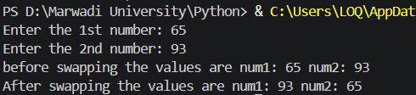

Conclusion: This problem teaches logic and memory storage by showing why a tracking variable (temp) is needed to safely trade values between two data locations without overwriting them.

Enrollment/Roll No: 92600565009

Practical No. 4

Aim/ Objective: Python Program to Find the Factorial of a Number

Source Code:
#Name: Jenil Makwana
#Enrollment: 92600565009

#Q.4 Python program to find factorial of number

num = int(input("Enter the number : "))

fact=1
for i in range (1,num+1):
fact *= i
print ("The factorial of given number is : ",fact)

Output:
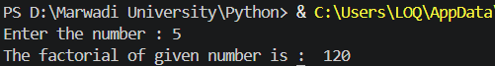

Conclusion: This code demonstrates a sequential loop calculation, showing how a single running product variable can repeatedly multiply growing numbers together to find a final mathematical total.

Enrollment/Roll No: 92600565009

Practical No. 5

Aim/ Objective: Python Program to Print the Fibonacci sequence

Source Code:
#Name: Jenil Makwana
#Enrollment: 92600565009

#Q.5 Python program to find fibonacci series

n=int(input("Enter the number: "))

a=0
b=1
for i in range (n):
a,b=b,a+b
print(a)

Output:
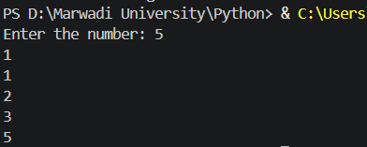

Conclusion: This exercise highlights variable updating and tracking, where two distinct numbers (a and b) pass changing values to each other dynamically to build a step-by-step sequence

Enrollment/Roll No: 92600565009

Practical No. 6

Aim/ Objective: Python program to print the elements of an array

Source Code:
#Name: Jenil Makwana
#Enrollment: 92600565009

#Q.6 Python program to print the elements of an array

arr = [10, 20, 30, 40, 50]

for i in arr:
print(i)

Output:
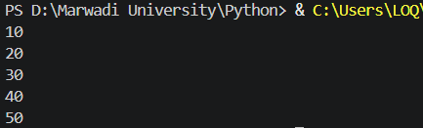

Conclusion: This script teaches array navigation, showing how a basic iterative loop sequentially unpacks a list to isolate and inspect elements one item at a time from start to finish.

Enrollment/Roll No: 92600565009

Practical No. 7

Aim/ Objective: Python program to print the largest element and smallest element in an array

Source Code:
#Name: Jenil Makwana
#Enrollment: 92600565009

#Q.7 Python program to print the largest element and smallest element in an array

arr = [23, 5, 89, 45, 12, 7]

largest = arr[0]
smallest = arr[0]

for i in arr:
if i > largest:
largest = i
if i < smallest:
smallest = i

print ("Largest element:", largest)
print ("Smallest element:", smallest)

Output:
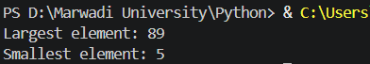

Conclusion: This program teaches conditional data filtering, using simple if comparisons inside a scanning loop to evaluate list items and track the current extreme values.

Enrollment/Roll No: 92600565009

Practical No. 8

Aim/ Objective: Python program to add two matrix using array and function

Source Code:
#Name: Jenil Makwana
#Enrollment: 92600565009

#Q.8 Python program to add two matrix using array and function

#Using array
a= [[1,2,3],[4,5,6],[7,8,9]]
b= [[9,8,7],[6,5,4],[3,2,1]]

for i in range (len (a)):
for j in range (len(a[0])):
print(a[i][j]+b[i][j], end=" ")
print ("")

#Using Function
def matrix_addition():
a= [[1,3,2],[5,4,6],[8,7,9]]
b= [[8,9,7],[4,6,5],[3,1,2]]

for i in range (len (a)):
for j in range (len(a[0])):
print(a[i][j]+b[i][j], end=" ")
print ("")

matrix_addition()

Output:
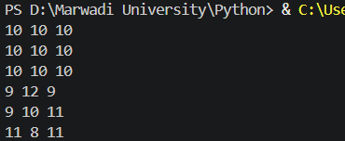

Conclusion: This structure demonstrates multi-dimensional indexing, utilizing a nested loop layout (a loop inside a loop) to target corresponding row and column intersections across distinct data grids.

Enrollment/Roll No: 92600565009

Practical No. 9

Aim/ Objective: Python program to print the sum of all elements in an array

Source Code:
#Name: Jenil Makwana
#Enrollment: 92600565009

#Q.9 Python program to print the sum of all elements in an array

arr = [10, 2, 30, 4, 50]

sum = 0

for i in arr:
sum += i

print ("Sum of all elements:",sum)

Output:
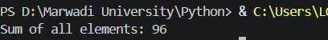

Conclusion: This problem highlights iterative value aggregation, using a linear loop to visit list elements sequentially and add their values to a single running total tracking variable.

Enrollment/Roll No: 92600565009

Practical No. 10

Aim/ Objective: Python Program to concatenate two strings

Source Code:
#Name: Jenil Makwana
#Enrollment: 92600565009

#Q.10 Python Program to concatenate two strings

s1= "hello"
s2= "world"

print(s1+" "+s2)

Output:
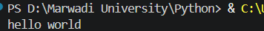

Conclusion: This logic shows how Python handles text combination, using the addition sign (+) as a simple text joining tool to merge individual pieces of string data together.

Enrollment/Roll No: 92600565009

Practical No. 11

Aim/ Objective: Python Program to demonstrate use of list and various functions of it.

Source Code:
#Name: Jenil Makwana
#Enrollment: 92600565009

#Q.11 Python Program to demonstrate use of list and various functions of it

print("Name: Jenil Makwana \n Enrollment: 92600565009")

numbers = [10, 20, 30, 40, 50]

print("The list is: ", numbers)

numbers.append(60)
print("After append: ", numbers)

numbers.insert(2, 25)
print("After insert: ", numbers)

numbers.remove(40)
print("After remove: ", numbers)

numbers.sort()
print("After sort: ", numbers)

numbers.reverse()
print("After reverse: ", numbers)

print("The length of list is: ", len(numbers))

Output:
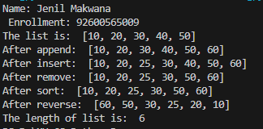

Conclusion: This logic demonstrates how Python handles lists, which are mutable data structures, using built-in functions like append(), insert(), remove(), sort(), and reverse() to actively modify and organize the stored elements.

Enrollment/Roll No: 92600565009

Practical No. 12

Aim/Objective: Python Program to demonstrate use of tuple and various functions of it.

Source Code:
#Q.12 Python Program to demonstrate use of list and various functions of it

#Name: Jenil Makwana
#Enrollment: 92600565009

#Q.12 Python Program to demonstrate use of tuple and various functions of it

print("Name: Jenil Makwana \n Enrollment: 92600565009")

numbers = (10, 20, 30, 20, 40, 50)

print("The tuple is: ", numbers)

print("The length of tuple is: ", len(numbers))

print("The count of 20 is: ", numbers.count(20))

print("The index of 30 is: ", numbers.index(30))

print("The maximum value is: ", max(numbers))

print("The minimum value is: ", min(numbers))

print("The sum of tuple is: ", sum(numbers))

Output:
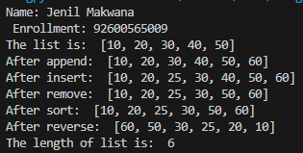

Conclusion: This logic shows how Python interacts with tuples. Since tuples are immutable, the program relies on read-only functions like count(), index(), max(), and min() to extract information and perform calculations.

Enrollment/Roll No: 92600565009

Practical No. 13

Aim/ Objective: Python Program to demonstrate the use of dictionary and various functions of it

Source Code:
#Q.13 Python Program to demonstrate the use of dictionary and various functions of it
#Name: Jenil Makwana
#Enrollment: 92600565009

print("Name: Jenil Makwana \n Enrollment: 92600565009")

student = {
"Name": "Jenil",
"Age": 22,
"Course": "MSc Cybersecurity"
}

print("The dictionary is: ", student)

print("The keys are: ", student.keys())

print("The values are: ", student.values())

print("The items are: ", student.items())

student["City"] = "Rajkot"
print("After adding City: ", student)

student.pop("Age")
print("After removing Age: ", student)

print("The length of dictionary is: ", len(student))

Output:
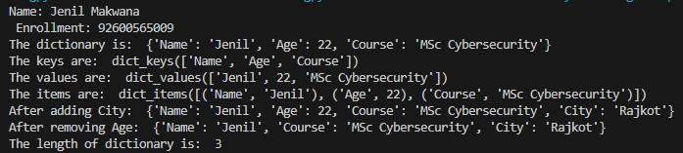

Conclusion: This program shows dictionary manipulation in Python, including accessing keys, values, and items, as well as adding and popping specific key-value pairs.

Enrollment/Roll No: 92600565009

Practical No. 14

Aim/Objective: Python Program to create a function

Source Code:
#Name: Jenil Makwana
#Enrollment: 92600565009

#Q.14 Python Program to create a function

print("Name: Jenil Makwana \n Enrollment: 92600565009")

def addition(num1, num2):
result = num1 + num2
print("The addition is: ", result)

num1 = int(input("Enter the First number: "))

num2 = int(input("Enter the Second number: "))

addition(num1, num2)

Output:
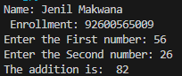

Conclusion: This logic covers the basics of modular programming in Python by defining a custom addition() function, taking dynamic user input, and performing the arithmetic block independently from the main execution flow.

Enrollment/Roll No: 92600565009

Practical No. 15

Aim/Objective: Python Program to demonstrate the use of various arguments which can be passed to functions

Source Code:
#Name: Jenil Makwana
#Enrollment: 92600565009

#Q.15 Python Program to demonstrate the use of various arguments which can be passed to functions

print("Name: Jenil Makwana \n Enrollment: 92600565009")

def student(name, age=21):
print("Student Name is: ", name)
print("Student Age is: ", age)

print("Using positional arguments:")
student("Jenil", 22)

print("Using keyword arguments:")
student(age=22, name="Rahul")

print("Using default arguments:")
student("Karan")

Output:
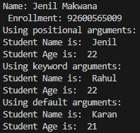

Conclusion: This logic demonstrates the flexibility of Python function parameters by successfully parsing data through standard positional arguments, explicitly mapped keyword arguments, and a fallback default argument when the user omits a parameter.

Enrollment/Roll No: 92600565009

Practical No. 16

Aim/Objective: Python Program to demonstrate the use of class

Source Code:
#Name: Jenil Makwana
#Enrollment: 92600565009

#Q.16 Python Program to demonstrate the use of class

print("Name: Jenil Makwana \n Enrollment: 92600565009")

class Student:
def display(self):
print("Student Name is: Jenil")
print("Student Course is: MSc Cybersecurity")
print("Student Age is: 22")

student1 = Student()

student1.display()

Output:
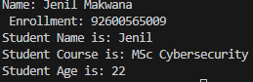

Conclusion: This logic introduces Object-Oriented Programming (OOP) in Python by encapsulating student details inside a Student class and demonstrating how to instantiate a discrete object to call the class's internal behavior.

Enrollment/Roll No: 92600565009

Practical No. 17

Aim/Objective: Python Program to demonstrate the concept of inner class

Source Code:
#Name: Jenil Makwana
#Enrollment: 92600565009

#Q.17 Python Program to demonstrate the concept of inner class

print("Name: Jenil Makwana \n Enrollment: 92600565009")

class Student:
def display(self):
print("This is the Student class")

class Address:
def display_address(self):
print("City: Rajkot")
print("Country: India")

student1 = Student()
student1.display()

address1 = student1.Address()
address1.display_address()

Output:
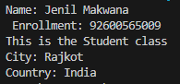

Conclusion: This logic illustrates nesting in Object-Oriented Programming by placing an Address class completely inside a Student class, showing how the inner class is dependent on the outer class namespace for instantiation.

Enrollment/Roll No: 92600565009

Practical No. 18

Aim/Objective: Python Program to demonstrate the use of methods

Source Code:
#Name: Jenil Makwana
#Enrollment: 92600565009

#Q.18 Python Program to demonstrate the use of methods

print("Name: Jenil Makwana \n Enrollment: 92600565009")

class Student:
def display(self):
print("Student Name is: Jenil")
print("Student Course is: MSc Cybersecurity")

student1 = Student()

student1.display()

Output:
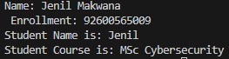

Conclusion: This logic serves as a straightforward example of binding a function (method) to a class object, using the self parameter to represent the current instance of the class that is executing the code.

Enrollment/Roll No: 92600565009

Practical No. 19

Aim/Objective: Python Program to demonstrate various types of methods

Source Code:
#Name: Jenil Makwana
#Enrollment: 92600565009

#Q.19 Python Program to demonstrate various types of methods

print("Name: Jenil Makwana \n Enrollment: 92600565009")

class Student:
def instance_method(self):
print("This is an instance method")

@classmethod
def class_method(cls):
print("This is a class method")

@staticmethod
def static_method():
print("This is a static method")

student1 = Student()

student1.instance_method()

Student.class_method()

Student.static_method()

Output:
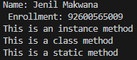

Conclusion: This logic breaks down the three distinct method scopes in Python OOP using decorators, contrasting an instance method, a @classmethod, and a @staticmethod.

Enrollment/Roll No: 92600565009

Practical No. 20(A)

Aim/Objective: Python Program to show method overloading by adding two numbers and three numbers using the same method name

Source Code:
#Name: Jenil Makwana
#Enrollment: 92600565009

#Q.20(a) Python Program to show method overloading by adding two numbers and three numbers using the same method name

print("Name: Jenil Makwana \n Enrollment: 92600565009")

class Addition:
def add(self, num1, num2, num3=0):
print("The addition is: ", num1 + num2 + num3)

addition = Addition()

addition.add(10, 20)

addition.add(10, 20, 30)

Output:
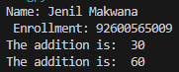

Conclusion: This logic replicates method overloading by cleverly utilizing a default argument, allowing the exact same add() method to handle varying numbers of inputs without throwing an error.

Enrollment/Roll No: 92600565009

Practical No. 20(B)

Aim/Objective: Python Program to show method overriding using a parent class Animal and a child class Dog

Source Code:
#Name: Jenil Makwana
#Enrollment: 92600565009

#Q.20(b) Python Program to show method overriding using a parent class Animal and a child class Dog

print("Name: Jenil Makwana \n Enrollment: 92600565009")

class Animal:
def sound(self):
print("Animal makes a sound")

class Dog(Animal):
def sound(self):
print("Dog barks")

animal = Animal()
animal.sound()

dog = Dog()
dog.sound()

Output:
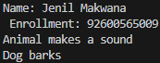

Conclusion: This logic demonstrates inheritance and polymorphism via method overriding, bro. By defining a sound() method inside the Dog child class, the program allows the child class to completely replace the parent's default behavior with its own specific output.

Enrollment/Roll No: 92600565009

Practical No. 21
Aim/ Objective: Write a Python program to show single inheritance using classes Animal and Dog.

Source Code:
#Name: Jenil Makwana
#Enrollment: 92600565009

# Q.21 Python Program to show single inheritance using classes Animal and Dog

print("Name: Jenil Makwana \n Enrollment: 92600565009")

class Animal:
def eat(self):
print("Animal can eat")

class Dog(Animal):
def bark(self):
print("Dog can bark")

dog = Dog()
dog.eat()
dog.bark()

Output:
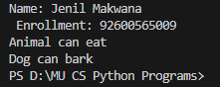

Conclusion: This program demonstrates single inheritance in Python, where the child class Dog inherits the properties and methods of the parent class

Enrollment/Roll No: 92600565009

Practical No. 22

Aim/ Objective: Python programs to demonstrate the use of various forms of inheritance

Source Code:
#Name: Jenil Makwana
#Enrollment: 92600565009

# Q.22 Python Program to demonstrate various forms of inheritance

print("Name: Jenil Makwana \n Enrollment: 92600565009")

# Single Inheritance
class Animal:
def eat(self):
print("Animal can eat")

class Dog(Animal):
def bark(self):
print("Dog can bark")

# Multilevel Inheritance
class Puppy(Dog):
def play(self):
print("Puppy can play")

# Hierarchical Inheritance
class Cat(Animal):
def meow(self):
print("Cat can meow")

print("\nSingle Inheritance:")
dog = Dog()
dog.eat()
dog.bark()

print("\nMultilevel Inheritance:")
puppy = Puppy()
puppy.eat()
puppy.bark()
puppy.play()

print("\nHierarchical Inheritance:")
cat = Cat()
cat.eat()
cat.meow()

Output:
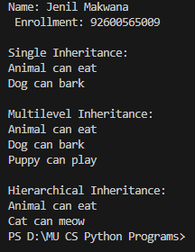

Conclusion: This program demonstrates different forms of inheritance in Python, including single, multilevel, and hierarchical inheritance, showing how classes can reuse and extend existing functionality.

Enrollment/Roll No: 92600565009

Practical No. 23

Aim/ Objective: Write a Python program to handle division by zero using try and except.

Source Code:
#Name: Jenil Makwana
#Enrollment: 92600565009

# Q.23 Python Program to handle division by zero using try and except

print("Name: Jenil Makwana \n Enrollment: 92600565009")

try:
num1 = int(input("Enter first number: "))
num2 = int(input("Enter second number: "))

result = num1 / num2
print("Result:", result)

except ZeroDivisionError:
print("Error: Cannot divide by zero.")

Output:
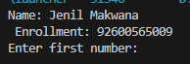

Conclusion: This program demonstrates the use of try and except to handle a division-by-zero error and prevent the program from terminating unexpectedly.

Enrollment/Roll No: 92600565009

Practical No. 24

Aim/ Objective: Write a Python program to handle invalid input entered by the user.

Source Code:
# Name: Jenil N Makwana
# Enrollment: 92600565009

# Q.24 Python Program to handle invalid input entered by the user

print("Name: Jenil N Makwana \nEnrollment: 92600565009")

try:
number = int(input("Enter a number: "))
print("You entered:", number)
except ValueError:
print("Error: Invalid input. Please enter a valid number.")

Output:
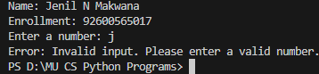

Conclusion: This program demonstrates how the try and except blocks can handle invalid user input using exception handling.

Enrollment/Roll No: 92600565009

Practical No. 25

Aim/ Objective: Write a Python program to use try–except–else block.

Source Code:
# Name: Jenil N Makwana
# Enrollment: 92600565009

# Q.25 Python Program to use try-except-else block

print("Name: Jenil N Makwana \nEnrollment: 92600565009")

try:
num1 = int(input("Enter first number: "))
num2 = int(input("Enter second number: "))
result = num1 / num2
except ZeroDivisionError:
print("Error: Cannot divide by zero.")
except ValueError:
print("Error: Please enter valid numbers.")
else:
print("Division successful.")
print("Result:", result)

Output:
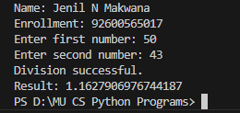

Conclusion: This program demonstrates the use of the try–except–else block, where the else block executes only when no exception occurs.

Enrollment/Roll No: 92600565009

Practical No. 26

Aim/ Objective: Write a Python program to use try–except–finally block.

Source Code:
# Name: Jenil N Makwana
# Enrollment: 92600565009

# Q.26 Python Program to use try-except-finally block

print("Name: Jenil N Makwana \nEnrollment: 92600565009")

try:
num1 = int(input("Enter first number: "))
num2 = int(input("Enter second number: "))
result = num1 / num2
print("Result:", result)
except ZeroDivisionError:
print("Error: Cannot divide by zero.")
except ValueError:
print("Error: Please enter valid numbers.")
finally:
print("This block is always executed.")

Output:
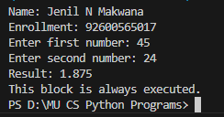

Conclusion: This program demonstrates the use of the try–except–finally block, where the finally block executes regardless of whether an exception occurs.

Enrollment/Roll No: 92600565009

Practical No. 27

Aim/ Objective: Python programs to demonstrate use of modules

Source Code:
# Name: Jenil N Makwana
# Enrollment: 92600565009

# Q.27 Python Program to demonstrate the use of modules

print("Name: Jenil N Makwana \nEnrollment: 92600565009")

import math
number = int(input("Enter a number: "))
print("Square root:", math.sqrt(number))
print("Factorial:", math.factorial(number))
print("Value of pi:", math.pi)

Output:
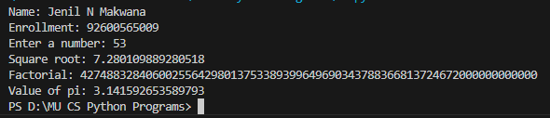

Conclusion: This program demonstrates the use of Python modules by importing the math module and using its built-in functions and constants.

Enrollment/Roll No: 92600565009

Practical No. 28

Aim/ Objective: Python programs to demonstrate the use of file handling

Source Code:
# Name: Jenil N Makwana
# Enrollment: 92600565009

# Q.28 Python Program to demonstrate the use of file handling

print("Name: Jenil N Makwana \nEnrollment: 92600565009")

file = open("student.txt", "w")
file.write("Name: Jenil N Makwana\n")
file.write("Enrollment: 92600565009\n")
file.close()

file = open("student.txt", "r")
content = file.read()
print("\nFile Content:")
print(content)
file.close()

Output:
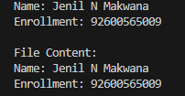

Conclusion: This program demonstrates basic file handling in Python by creating, writing, reading, and closing a file

Enrollment/Roll No: 92600565009

Practical No. 29

Aim/ Objective: Python Programs to demonstrate the use of various modes of files

Source Code:
# Name: Jenil N Makwana
# Enrollment: 92600565009

# Q.29 Python Program to demonstrate the use of various modes of files

print("Name: Jenil N Makwana \nEnrollment: 92600565009")

# Write mode
file = open("demo.txt", "w")
file.write("This is the first line.\n")
file.close()

# Append mode
file = open("demo.txt", "a")
file.write("This is the second line.\n")
file.close()

# Read mode
file = open("demo.txt", "r")
print("File Content:")
print(file.read())
file.close()

Output:
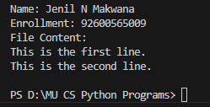

Conclusion: This program demonstrates different file modes such as write (w), append (a), and read (r) for performing various file operations.

Enrollment/Roll No: 92600565009

Practical No. 30

Aim/ Objective: Python programs to demonstrate the use of regular expression.

Source Code:
# Name: Jenil N Makwana
# Enrollment: 92600565009

# Q.30 Python Program to demonstrate the use of regular expression

print("Name: Jenil N Makwana \nEnrollment: 92600565009")

import re
text = "My enrollment number is 92600565009."
pattern = r"\d+"
result = re.findall(pattern, text)
print("Numbers found in the text:", result)

Output:
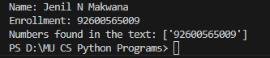

Conclusion: This program demonstrates different file modes such as write (w), append (a), and read (r) for performing various file operations.

Enrollment/Roll No: 92600565009

Practical No. 31

Aim/ Objective: Write a Python program to connect Python with MySQL database and display a message “Database Connected Successfully”

Source Code:
# Name: Jenil N Makwana
# Enrollment: 92600565009

# Q.31 Python Program to connect Python with MySQL database

print("Name: Jenil N Makwana \nEnrollment: 92600565009")

import mysql.connector

mydb = mysql.connector.connect(
host="localhost",
user="root",
password=""
)

if mydb.is_connected():
print("Database Connected Successfully")

mydb.close()

Output:
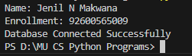

Conclusion: This program demonstrates how to connect Python with a MySQL database and display a successful connection message.

Enrollment/Roll No: 92600565009

Practical No. 32

Aim/ Objective: Write a Python program to create a table, insert records, retrieve and display records from a table.

Source Code:
# Name: Jenil N Makwana
# Enrollment: 92600565009

# Q.32 Python Program to create table, insert and display records

print("Name: Jenil N Makwana \nEnrollment: 92600565009")

import mysql.connector

mydb = mysql.connector.connect(
host="localhost",
user="root",
password=""
)

mycursor = mydb.cursor()
mycursor.execute("CREATE DATABASE IF NOT EXISTS assignment_db")
mycursor.execute("USE assignment_db")

mycursor.execute("""
CREATE TABLE IF NOT EXISTS students (
id INT PRIMARY KEY,
name VARCHAR(50),
age INT
)
""")

mycursor.execute("DELETE FROM students")

sql = "INSERT INTO students (id, name, age) VALUES (%s, %s, %s)"
values = [
(1, "Jenil", 21),
(2, "Rahul", 21),
(3, "Priya", 23)
]

mycursor.executemany(sql, values)
mydb.commit()

print("Records inserted successfully")

mycursor.execute("SELECT * FROM students")
records = mycursor.fetchall()

print("Student Records:")
for row in records:
print(row)

mydb.close()

Output:
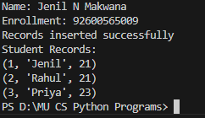

Conclusion: This program demonstrates how to create a table in a MySQL database, insert records, retrieve and display the stored records.

Enrollment/Roll No: 92600565009

Practical No. 33

Aim/ Objective: Write a Python program to update the records into a MySQL table and display records.

Source Code:
# Name: Jenil N Makwana
# Enrollment: 92600565009

# Q.33 Python Program to update records in MySQL table

print("Name: Jenil N Makwana \nEnrollment: 92600565009")

import mysql.connector

mydb = mysql.connector.connect(
host="localhost",
user="root",
password=""
)

mycursor = mydb.cursor()
mycursor.execute("CREATE DATABASE IF NOT EXISTS assignment_db")
mycursor.execute("USE assignment_db")

mycursor.execute("""
CREATE TABLE IF NOT EXISTS students (
id INT PRIMARY KEY,
name VARCHAR(50),
age INT
)
""")

# Inserting initial record using your name
mycursor.execute("""
INSERT INTO students VALUES (1, 'Jenil', 21)
ON DUPLICATE KEY UPDATE name='Jenil', age=21
""")
mydb.commit()

# Updating the age
sql = "UPDATE students SET age = %s WHERE id = %s"
values = (22, 1)
mycursor.execute(sql, values)
mydb.commit()

print("Record updated successfully")

mycursor.execute("SELECT * FROM students")
records = mycursor.fetchall()

print("Updated Student Records:")
for row in records:
print(row)

mydb.close()

Output:
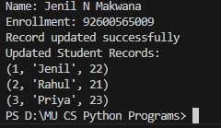

Conclusion: This program demonstrates how to update existing records in a MySQL table and display the updated records.

Enrollment/Roll No: 92600565009

Practical No. 34

Aim/ Objective: Write a Python program to delete the records into a MySQL table and display records

Source Code:
# Name: Jenil N Makwana
# Enrollment: 92600565009

# Q.34 Python Program to delete records from MySQL table

print("Name: Jenil N Makwana \nEnrollment: 92600565009")

import mysql.connector

mydb = mysql.connector.connect(
host="localhost",
user="root",
password=""
)

mycursor = mydb.cursor()
mycursor.execute("CREATE DATABASE IF NOT EXISTS assignment_db")
mycursor.execute("USE assignment_db")

mycursor.execute("""
CREATE TABLE IF NOT EXISTS students (
id INT PRIMARY KEY,
name VARCHAR(50),
age INT
)
""")

# Re-inserting the record so we have something to delete
mycursor.execute("""
INSERT INTO students VALUES (1, 'Jenil', 21)
ON DUPLICATE KEY UPDATE name='Jenil', age=21
""")
mydb.commit()

# Deleting the record we just inserted
sql = "DELETE FROM students WHERE id = %s"
value = (1,)
mycursor.execute(sql, value)
mydb.commit()

print("Record deleted successfully")

mycursor.execute("SELECT * FROM students")
records = mycursor.fetchall()

print("Remaining Student Records:")
for row in records:
print(row)

mydb.close()

Output:
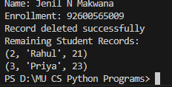

Conclusion: This program demonstrates how to delete records from a MySQL table and display the remaining records.

Enrollment/Roll No: 92600565009

Practical No. 35

Aim/ Objective: Python Program to demonstrate the use of DataFrames in python

Source Code:
# Name: Jenil N Makwana
# Enrollment: 92600565009

# Q.35 Python Program to demonstrate the use of DataFrames

print("Name: Jenil N Makwana \nEnrollment: 92600565009")

import pandas as pd

data = {
"Name": ["Jenil", "Rahul", "Priya"],
"Age": [21, 21, 23],
"City": ["Ahmedabad", "Rajkot", "Surat"]
}

df = pd.DataFrame(data)

print("Student DataFrame:")
print(df)

print("\nDataFrame Information:")
print(df.info())

print("\nFirst Two Records:")
print(df.head(2))

Output:
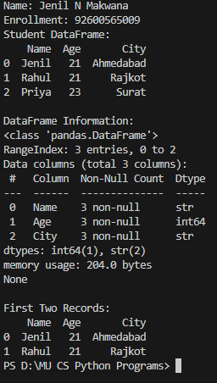

Conclusion: This program demonstrates the use of Pandas DataFrames to store, organize and display data in tabular form.

Enrollment/Roll No: 92600565009

Practical No. 36

Aim/ Objective: Python Programs to demonstrate different ways of creating DataFrames

Source Code:
# Name: Jenil N Makwana
# Enrollment: 92600565009

# Q.36 Python Program to demonstrate different ways of creating DataFrames

print("Name: Jenil N Makwana \nEnrollment: 92600565009")

import pandas as pd

# Method 1: Using Dictionary
data1 = {
"Name": ["Jenil", "Rahul"],
"Age": [21, 21]
}
df1 = pd.DataFrame(data1)
print("DataFrame using Dictionary:")
print(df1)

# Method 2: Using List
data2 = [
["Jenil", 21],
["Rahul", 21],
["Priya", 23]
]
df2 = pd.DataFrame(data2, columns=["Name", "Age"])
print("\nDataFrame using List:")
print(df2)

# Method 3: Using List of Dictionaries
data3 = [
{"Name": "Jenil", "Age": 21},
{"Name": "Rahul", "Age": 21}
]
df3 = pd.DataFrame(data3)
print("\nDataFrame using List of Dictionaries:")
print(df3)

# Method 4: Using Series
data4 = {
"Name": pd.Series(["Jenil", "Rahul"]),
"Age": pd.Series([21, 21])
}
df4 = pd.DataFrame(data4)
print("\nDataFrame using Series:")
print(df4)

Output:
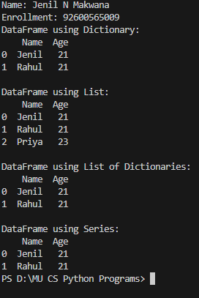

Conclusion: This program demonstrates different methods of creating Pandas DataFrames using dictionaries, lists, lists of dictionaries and series.
Enrollment/Roll No: 92600565009

Practical No. 37

Aim/ Objective: Python Programs to create Pie chart

Source Code:
# Name: Jenil N Makwana
# Enrollment: 92600565009

# Q.37 Python Program to create Pie Chart
print("Name: Jenil N Makwana \nEnrollment: 92600565009")
import matplotlib.pyplot as plt
subjects = ["Python", "Java", "C++", "PHP"]
marks = [85, 75, 65, 55]
plt.pie(marks, labels=subjects, autopct="%1.1f%%")
plt.title("Subject Marks Distribution")
plt.show()
Output:
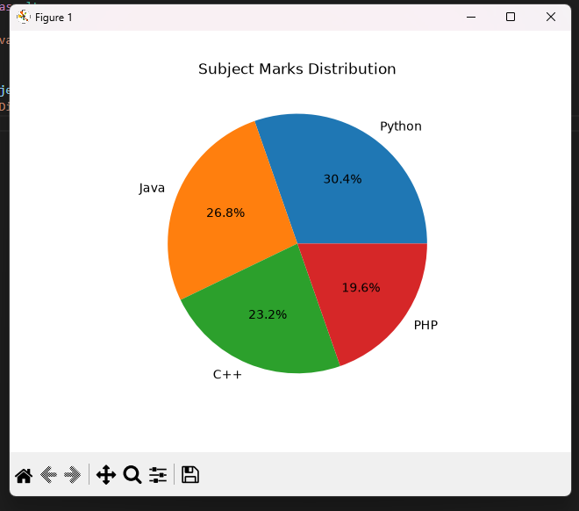

Enrollment/Roll No: 92600565009

Practical No. 38

Aim/ Objective: Python Programs to create histogram

Source Code:
# Name: Jenil N Makwana
# Enrollment: 92600565009
# Q.38 Python Program to create Histogram
print("Name: Jenil N Makwana \nEnrollment: 92600565009")
import matplotlib.pyplot as plt
marks = [45, 55, 60, 65, 70, 75, 80, 85, 90, 95]
plt.hist(marks, bins=5, edgecolor="black")
plt.title("Marks Distribution")
plt.xlabel("Marks")
plt.ylabel("Number of Students")
plt.show()
Output:
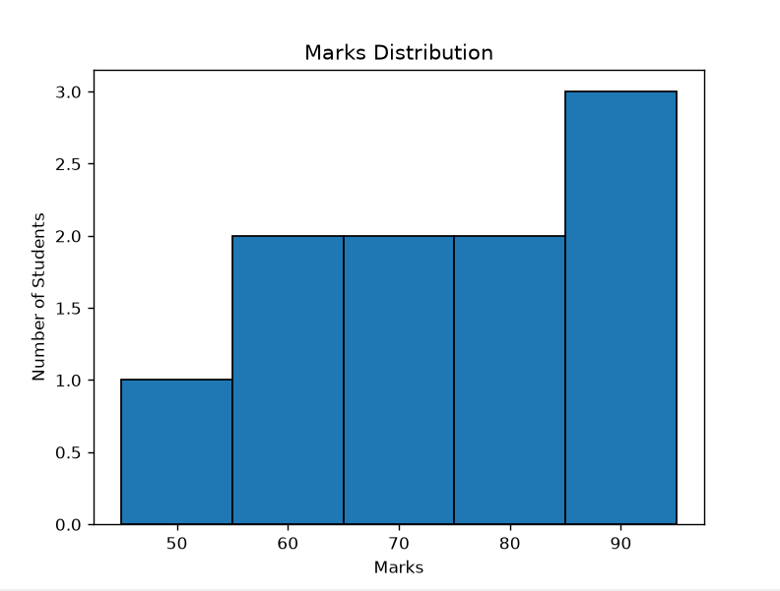

Conclusion: This program demonstrates how to create a histogram using Matplotlib to represent the frequency distribution of numerical data.
Enrollment/Roll No: 92600565009

Practical No. 39

Aim/ Objective: Python Programs to create bar graph
Source Code:
# Name: Jenil N Makwana
# Enrollment: 92600565009
# Q.39 Python Program to create Bar Graph
print("Name: Jenil N Makwana \nEnrollment: 92600565009")
import matplotlib.pyplot as plt
subjects = ["Python", "Java", "C++", "PHP"]
marks = [85, 75, 65, 55]
plt.bar(subjects, marks)
plt.title("Student Marks")
plt.xlabel("Subjects")
plt.ylabel("Marks")
plt.show()
Output:
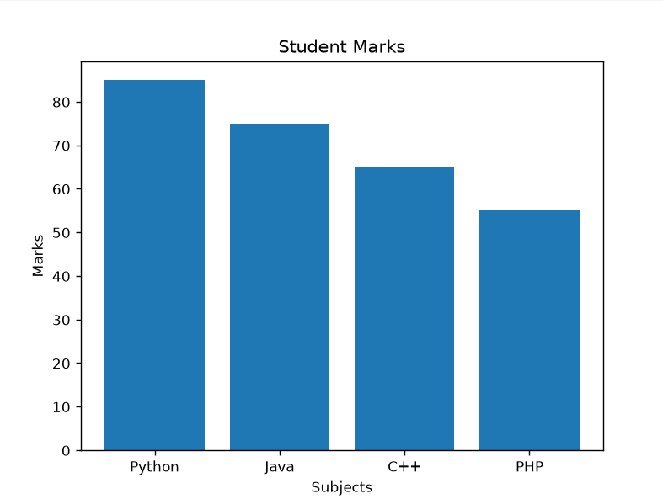

Conclusion: This program demonstrates how to create a bar graph using Matplotlib to compare values across different categories.

Enrollment/Roll No: 92600565009

Practical No. 40

Aim/ Objective: Python Programs to create Line graph
Source Code:
# Name: Jenil N Makwana
# Enrollment: 92600565009

# Q.40 Python Program to create Line Graph
print("Name: Jenil N Makwana \nEnrollment: 92600565009")
import matplotlib.pyplot as plt
months = ["Jan", "Feb", "Mar", "Apr", "May"]
sales = [100, 150, 120, 180, 200]
plt.plot(months, sales, marker="o")
plt.title("Monthly Sales Report")
plt.xlabel("Months")
plt.ylabel("Sales")
plt.grid(True)
plt.show()
Output:
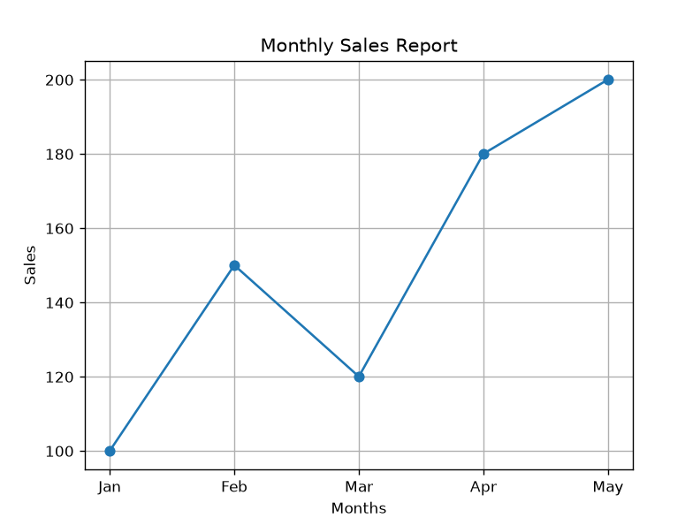

Conclusion: This program demonstrates how to create a line graph using Matplotlib to represent data trends over a period of time.
Enrollment/Roll No: 92600565009

Practical No. 41

Aim/ Objective: Write a Python program to perform a WHOIS lookup for a given domain name and display the result.

Source Code:
# Name: Jenil N Makwana
# Enrollment: 92600565009
# Q.41 Python Program to perform WHOIS lookup
print("Name: Jenil N Makwana \nEnrollment: 92600565009")

import whois

domain = "google.com"
result = whois.whois(domain)

print("WHOIS Information:")
print(result)

Output:
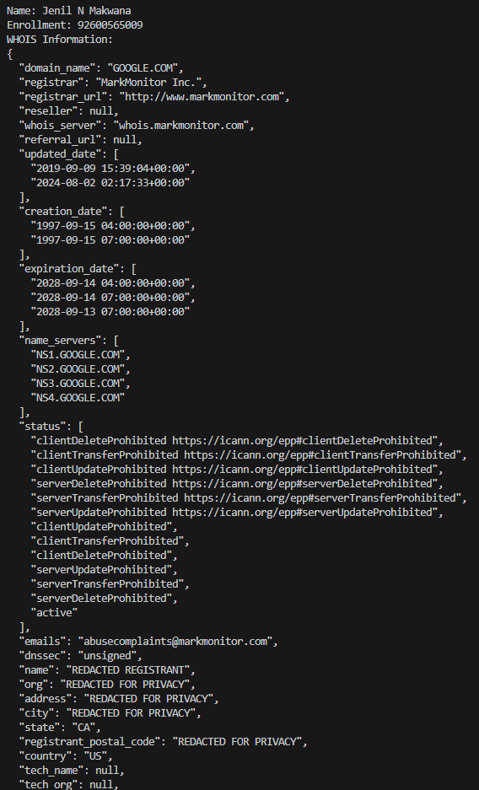

Conclusion: This program demonstrates how to perform a WHOIS lookup to retrieve and display registration information about a given domain name.

Enrollment/Roll No: 92600565009

Practical No. 42

Aim/ Objective: Write a Python program to accept a domain name from the user and show basic WHOIS information

Source Code:
# Name: Jenil N Makwana
# Enrollment: 92600565009
# Q.42 Python Program to accept domain name and display WHOIS information
print("Name: Jenil N Makwana \nEnrollment: 92600565009")

import whois

domain = input("Enter Domain Name: ")
result = whois.whois(domain)

print("\nWHOIS Information:")
print("Domain Name:", result.domain_name)
print("Registrar:", result.registrar)
print("Creation Date:", result.creation_date)
print("Expiration Date:", result.expiration_date)

Output:
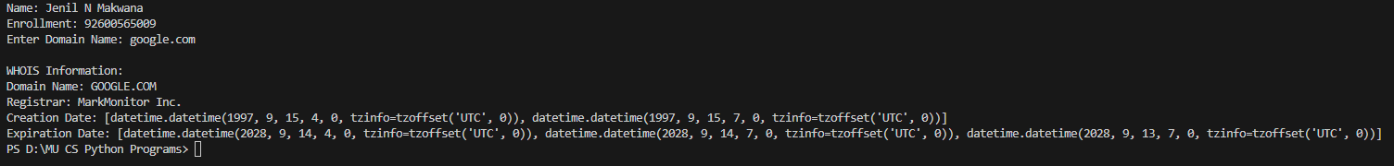

Conclusion: This program demonstrates how to accept a domain name from the user and display its basic WHOIS information.

Enrollment/Roll No: 92600565009

Practical No. 43

Aim/ Objective: Write a Python program to display the domain registrar name using WHOIS.

Source Code:
# Name: Jenil N Makwana
# Enrollment: 92600565009
# Q.43 Python Program to extract Name Servers and Emails using WHOIS
print("Name: Jenil N Makwana \nEnrollment: 92600565009")

import whois
domain = input("Enter Domain Name: ")
result = whois.whois(domain)
print("\nDomain Name:", domain)
print("Registrar Name:", result.registrar)
Output:
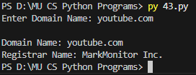

Conclusion: This program demonstrates how to retrieve and display the registrar name of a domain using the WHOIS library.

Enrollment/Roll No: 92600565009

Practical No. 44

Aim/ Objective: Write a Python program to display the domain creation date using WHOIS.

Source Code:
# Name: Jenil N Makwana
# Enrollment: 92600565009
# Q.44 Python Program to display domain creation date using WHOIS

print("Name: Jenil N Makwana \nEnrollment: 92600565009")

import whois
domain = input("Enter Domain Name: ")
result = whois.whois(domain)
print("\nDomain Name:", domain)
print("Creation Date:", result.creation_date)
Output:
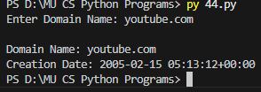

Conclusion: This program demonstrates how to retrieve and display the creation date of a domain using the WHOIS library

Enrollment/Roll No: 92600565009

Practical No. 45

Aim/ Objective: Write a Python program to use the dig command to find the IP address of a website (example: google.com). Also, display the DNS records of a given domain.

Source Code:
# Name: Jenil N Makwana
# Enrollment: 92600565009
# Q.45 Python Program to perform DNS lookup
print("Name: Jenil N Makwana \nEnrollment: 92600565009")

import subprocess

domain = "google.com"
print(f"--- Running DNS lookup for {domain} ---")

try:
# Using 'nslookup' since 'dig' is not native to Windows
result = subprocess.run(["nslookup", domain], capture_output=True, text=True, check=True)

print("\nDNS Records:")
print(result.stdout)

except FileNotFoundError:
print("\nError: The command is not installed on this system.")
except subprocess.CalledProcessError as e:
print(f"\nCommand failed with error: {e}")

Output:
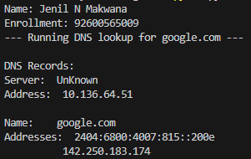

Conclusion: This program demonstrates how to use the dig command to find the IP address of a website and retrieve DNS records of a given domain.

Enrollment/Roll No: 92600565009

Practical No. 46

Aim/ Objective: Python Program using re — Detect Emails Using Regular Expressions

Source Code:
# Name: Jenil N Makwana
# Enrollment: 92600565009
# Q.46 Python Program to generate hash of a string
print("Name: Jenil N Makwana \nEnrollment: 92600565009")

import hashlib

text = "SafeThinker Cybersecurity"
print(f"Original Text: {text}\n")

# MD5 Hash
md5_hash = hashlib.md5(text.encode()).hexdigest()
print(f"MD5 Hash: {md5_hash}")

# SHA-256 Hash
sha256_hash = hashlib.sha256(text.encode()).hexdigest()
print(f"SHA-256 Hash: {sha256_hash}")

Output:
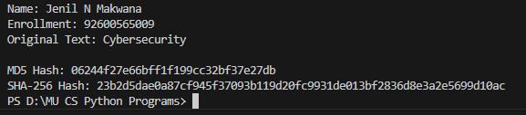

Conclusion: This program demonstrates how to use regular expressions with the re module to identify and extract email addresses from a given text.

Enrollment/Roll No: 92600565009

Practical No. 47

Aim/ Objective: Python Program using socket — Simple Port Scanner

Source Code:
# Name: Jenil N Makwana
# Enrollment: 92600565009
# Q.47 Python Program to display current working directory and list files
print("Name: Jenil N Makwana \nEnrollment: 92600565009")

import os

# Get current working directory
cwd = os.getcwd()
print(f"Current Working Directory: {cwd}\n")
# List all files and directories in the current path
print("Contents of the directory:")
contents = os.listdir(cwd)
for item in contents:
print("-", item)

Output:
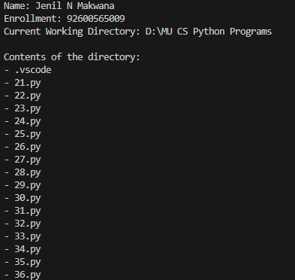

Conclusion: This program demonstrates how to use the socket library to scan ports on a target system and identify open ports.
Enrollment/Roll No: 92600565009

Practical No. 48

Aim/ Objective: Program to generate hash values of a string using hashlib library

Source Code:
# Name: Jenil N Makwana
# Enrollment: 92600565009
# Q.48 Python Program to demonstrate Exception Handling
print("Name: Jenil N Makwana \nEnrollment: 92600565009\n")

try:
# Taking input from the user
num1 = int(input("Enter the numerator: "))
num2 = int(input("Enter the denominator: "))

# Attempting division
result = num1 / num2
print(f"Result of division: {result}")

except ZeroDivisionError:
print("Error: Cannot divide a number by zero!")

except ValueError:
print("Error: Please enter valid integer numbers only!")

finally:
print("\nExecution of the try-except block is complete.")

Output:
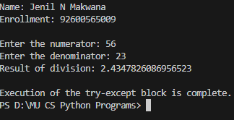

Conclusion: This program demonstrates how to generate MD5 and SHA-256 hash values of a given string using the hashlib library.

Enrollment/Roll No: 92600565009

Practical No. 49

Aim/ Objective: Python Program using os Library — Check Files in a Directory

Source Code:
# Name: Jenil N Makwana
# Enrollment: 92600565009
# Q.49 Python Program to demonstrate File I/O operations
print("Name: Jenil N Makwana \nEnrollment: 92600565009\n")

filename = "sample.txt"

# Writing data to a file
with open(filename, "w") as file:
file.write("Hello, this is a test file for Practical 49.\n")
file.write("SafeThinker Cybersecurity is going to be awesome!")

print(f"Data successfully written to '{filename}'.")

# Reading data back from the file
print("\nReading data from the file:")
print("-" * 30)

with open(filename, "r") as file:
content = file.read()
print(content)

print("-" * 30)

Output:
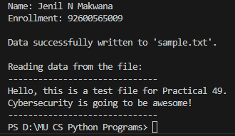

Conclusion: This program demonstrates how to use the os library to check a directory and display the files present in it.

Enrollment/Roll No: 92600565009

Practical No. 50

Aim/ Objective: Python program for Ping Scanner shows ip up or down

Source Code:
# Name: Jenil N Makwana
# Enrollment: 92600565009
# Q.50 Python Program to demonstrate Classes and Objects
print("Name: Jenil N Makwana \nEnrollment: 92600565009\n")

# Defining the class
class Student:
def __init__(self, name, enrollment):
self.name = name
self.enrollment = enrollment

def display_info(self):
print("--- Student Record ---")
print(f"Name: {self.name}")
print(f"Enrollment Number: {self.enrollment}")

# Creating an object of the Student class using your details
student1 = Student("Jenil N Makwana", "92600565009")

# Calling the method to display the data
student1.display_info()

Output:
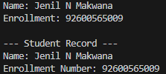

Conclusion: This program demonstrates how to use the ping command through Python to check whether a given IP address is reachable (UP) or unreachable (DOWN).

